Directions: Solve the following systems of equations by graphing.
$y+5=4x$ $3y=\text{24}−x$ $y+2x=3$ $2y+\text{14}=x$

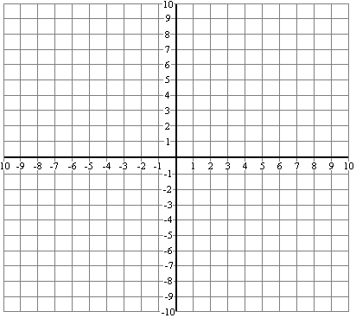

$x=$__________ $y=$__________ $x=$__________ $y=$__________

Directions: Solve the following systems of inequalities by graphing.

$y<\frac{2}{5}x−4$ $y+2x≥8$ $−3y≥x+6$ $8y+\text{16}>2x$

Directions: Solve the following systems of equations by substitution or combination (your choice!).

$y=5x−8$ $y=−3x−4$ $6x=5+y$ $6y+6=4x$
$2y=x−7$ $2x=y−6$ $\text{12}x−2y=\text{10}$ $3y=2x+9$

$x=$______ $y=$______ $x=$______ $y=$______ $x=$______ $y=$______ $x=$______ $y=$______

